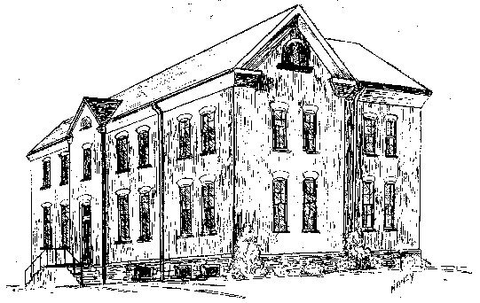

St. Michael School
214 Keuka St. Phone: 315-536-6112
Penn Yan, NY 14527 Fax: 315-536-6112
Email: smpydcs@dor.org

Continuing the Tradition of Debra Marvin, Principal
Academic Excellence

TUITION SCHEDULE 2023 – 2024

The tuition schedule for the 2023-24 school year is outlined below. We are pleased to continue to make a St. Michael’s education affordable to all families in our community. To apply for financial assistance, please complete the online application using your FACTS account. The online application is available effective immediately. This process is completely confidential; only the principal will review your application. The initial deadline for applications is April 1, 2023.

Tuition Schedule

Pre-School (Half-Day: Tuesday and Thursday) $1,820 per school year □
Pre-School (Full-Day: Tuesday and Thursday) $2,075 per school year □

Pre-K – 3 days $2,525 per school year □
Pre-K – 5 days $4,050 per school year □

**** Multi-student rates are available: Contact Mrs. Marvin for family rates. ****

K-5 Parishioner Rates Annual Tuition K-5 Non-Parishioner Rates Annual Tuition
1 child $ 5,000.00 □ 1 child $ 5,825.00 □
2 children 6,800.00 □ 2 children 6,900.00 □
3 children 7,550.00 □ 3 children 7,500.00 □
4+children 8,175.00 □ 4+ children 8,950.00 □
Select One Payment Option

 Option 1: We agree to pay the full amount for the year prior to August 31st. A 10% discount
will be applied to the account if paid in full by August 31st.

 Option 2: We agree to pay semi-annually in two installments before August 31st and January
31st through the FACTS Management System.

 Option 3: We agree to pay in 10 monthly payments through the FACTS Management System.

