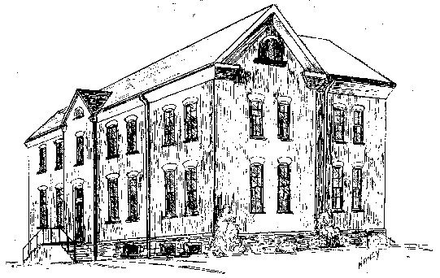

St. Michael School
214 Keuka St. Phone: 315-536-6112
Penn Yan, NY 14527 Fax: 315-536-6112
Email: smpydcs@dor.org

Continuing the Tradition of Debra Marvin, Principal
Academic Excellence

Medical History Form

Date: ______________________________

Name of Child: ____________________________________________________________________________________
Last First Middle

M _______ F _______ Date of Birth: ___________________________ (Month/Day/Year)

Parent/Guardian Name: ____________________________________________________________________________

Name of Physician: _________________________________ Name of Dentist: ______________________________

Parent/Guardian: If you answer yes to any of the following questions, please explain your answer in the comment section at the end of the form.

Is your child currently under a physician’s care? Yes _____ No _____
If yes, for what reason?
__________________________________________________________________________________________________

Is your child currently taking medication? Yes _____ No _____
If yes, name of medication(s): _________________________________________________________________________

Will your child need medication at school? Yes _____ No _____
If yes, type ________________________________________________________________________________________

Has your child even been hospitalized and/or seen in emergency for illness, surgery, or injury? Yes _____ No _____
If yes, explain _____________________________________________________________________________________

Did you have any difficulty during pregnancy, labor or delivery? Yes _____ No _____
If yes, explain _____________________________________________________________________________________

Was your child premature? Yes _____ No _____

At what age did your child toilet train? Bladder __________ Bowel __________

OVER

Health History
Has your child had or does he/she now have any of the following?

YES NO YES NO
Pneumonia _____ _____ Frequent high fevers _____ _____
Chicken Pox _____ _____ Dizzy spells _____ _____
Severe menstrual problems _____ _____ Meningitis _____ _____
Emotional difficulties _____ _____ Severe headaches _____ _____
Nervous disorders _____ _____ Head injury – unconsciousness _____ _____
Hyperactivity _____ _____ Toileting issues _____ _____
Seizures/Convulsions _____ _____ Strep throat _____ _____
Joint Disease _____ _____ Heart disease _____ _____
Lead poisoning _____ _____ Fainting spells _____ _____
Diabetes _____ _____

Fractures Yes _____ No _____
If yes, type ________________________________________________________________________________________

Frequent ear infections Yes _____ No _____

Hearing difficulties Yes _____ No _____ If yes, does your child have hearing aids or tubes? ________________

Vision difficulties Yes _____ No _____ If yes, has your child seen an eye doctor/wear glasses? ____________

Asthma Yes _____ No _____
List triggers: ________________________________________________________________________________
Treatment for symptoms: ______________________________________________________________________
Will your child need an inhaler or nebulizer at school? Yes _____ No _____

Allergies Yes _____ No _____
Types: _____________________________________________________________________________________
Treatment: _________________________________________________________________________________
List triggers: ________________________________________________________________________________
Will your child need Benedryl or an EpiPen at school? Yes _____ No _____

Is there anything else about your child’s health, past or present, that the school district should be aware of in order to provide the best possible learning experience?

I understand that in the event of a medical emergency, an ambulance will be called to take my child to the hospital. I realize that St. Michael School cannot assume the responsibility for the payment of medical fees or expenses incurred as a result of any medical emergency.

Parent/Guardian Signature: __________________________________________________ Date: ___________________

If you child has health concerns, please contact the appropriate Health Office to schedule an appointment to discuss his/her health in detail.

/bab/medical history form - revised 11/15/11

