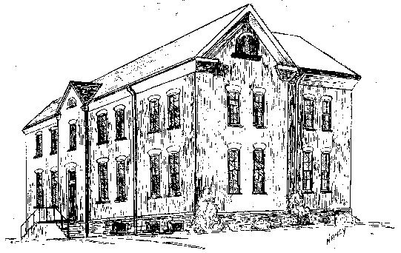

St. Michael School
214 Keuka St. Phone: 315-536-6112
Penn Yan, NY 14527 Fax: 315-536-6112
Email: smpydcs@dor.org

Continuing the Tradition of Debra Marvin, Principal
Academic Excellence

St. Michael School Activity Center

St. Michael School offers a before and after school program, the Activity Center, which provides supervised activities for children enrolled in the school. The Activity Center is available to
St. Michael School children in grades preschool through grade 5 on days when school is in session.

When school is open on a delayed basis due to weather, etc. the Activity Center will open on the normal schedule. If school is subsequently cancelled, children must be picked up by noon. The Activity Center will not be open on holidays or snow days.

The Activity Center will offer age appropriate activities in 4 different categories (centers):

- quiet games (puzzles, board games, etc.) and reading
- building blocks and Legos
- toys
- arts and crafts

In addition, the playground will be utilized on good weather days.

Normal hours for the Activity Center are 7:00 – 8:30 a.m. and 3:00 – 5:30 p.m.
Children are dismissed from the Activity Center to the classrooms at 8:30 a.m. and return to the Activity Center at 3:00 p.m.

Fees: $5.00 per hour for 1 child
$7.50 per hour for 2 children
$8.00 per hour for 3 children

Each child needs to be signed in and out on a daily basis. Fees rounded up to the quarter hour.

Late fee: The Activity Center closes at 5:30 p.m. Please pick up your child by then. A fee of
$5.00 per quarter hour past 5:30 is charged for late pick up. Children will of course be supervised until parent arrives. Please call ahead if possible when a late pick up will occur.

The Activity Center is run by Mrs. Webber and Mrs. Cramer.

ST. MICHAEL SCHOOL
BEFORE AND AFTER SCHOOL PROGRAM

Family’s Last Name: ______________________________________________________

Address: ________________________________________________________________

City and Zip Code: ________________________________________________________

Telephone Number: _______________________________________________________

Mother’s Name: __________________________________________________________

Work Phone #: _____________________ Home Phone #: ______________________

Cell Phone #: ______________________ Pager #: ____________________________

Father’s Name: ___________________________________________________________

Work Phone #: _____________________ Home Phone #: ______________________

Cell Phone #: ______________________ Pager #: ____________________________

Please list name, address and telephone number of people other than you to contact in case of emergency.

- ______________________________________________________________

Relationship to child/children: __________________________________

- _______________________________________________________________

Relationship to child/children: __________________________________

Only those adults listed on this form will have the authority to pick up your child/children. It is very important that you keep us updated regarding any additions or deletions to this list as they occur! Any changes must be in writing to the Program Director.

Child/Children’s Name(s): __________________________________________________

